1. Open ProductController.java and create new API

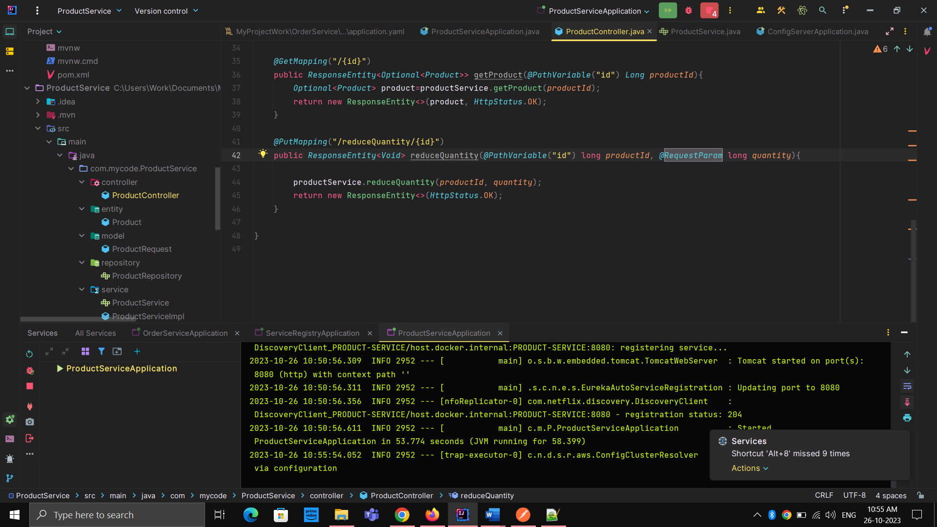



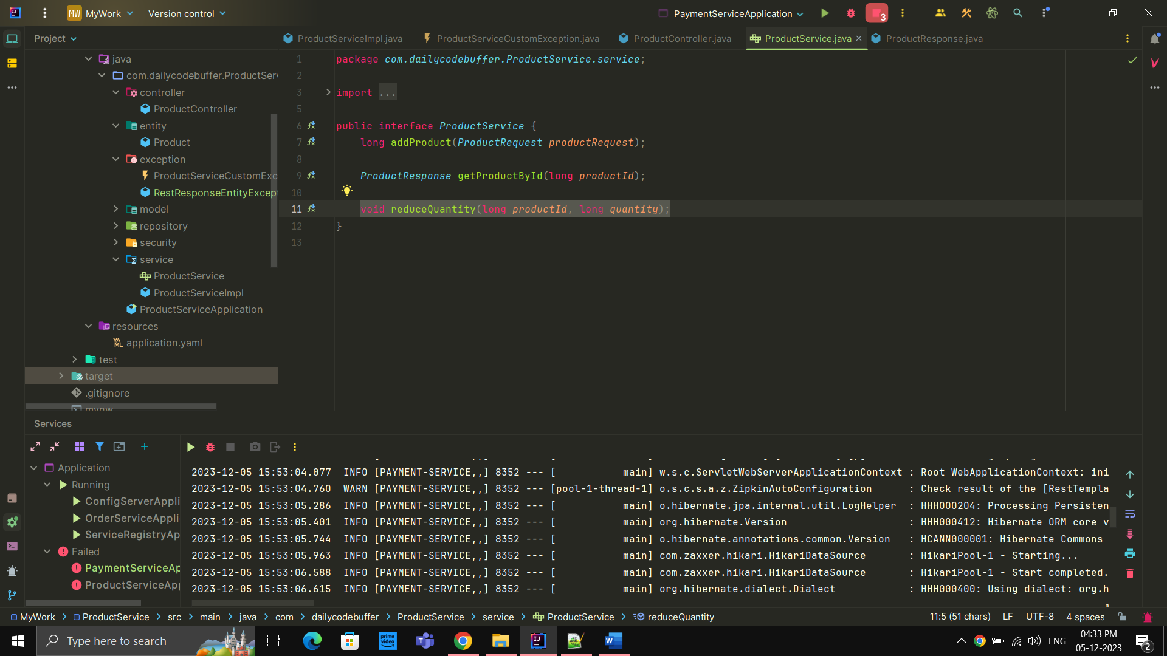



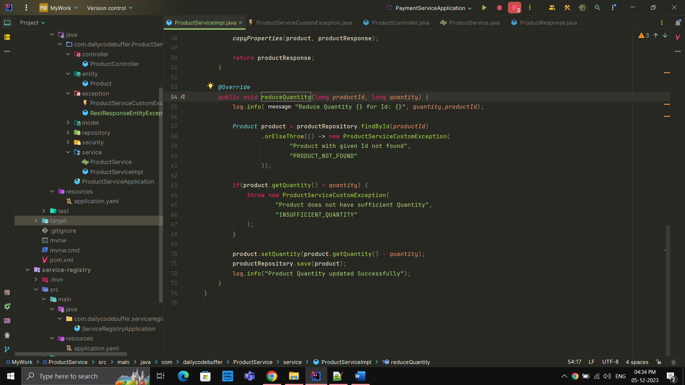

1. Open POSTMAN and hit the request

<http://localhost:8080/product/reduceQuantity/1?quantity=1>

(we used @RequestParam long quantity that’s why we use ?quantity=1)